## CORE JAVA 8 -WHOLE PRACTICE ASSIGNMENT

1. Create a Student table in the database with student id, student name, total marks.
2. Create a java application with four options.

Option one to create a student in the database from the details the user entered in the console.

Option two is to get the details of one student, using the id entered by the user in the console.

Option three to get all student details and store in a List. Implement a Comparable interface and sort the list using total marks and display.

Option four to get the student who has the highest total marks. Store that student object in a file using serialization.

Create a service interface and service implementation class and create the Dao interface and Dao implementation class for the project.

Solution:

1. Create a Student table in the database with student id, student name, total marks.

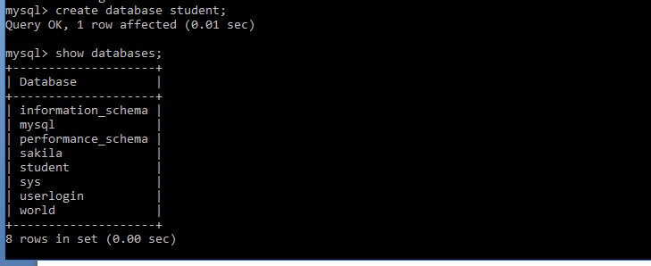

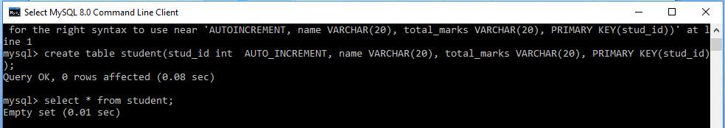

1. Create a java application with four options.

Option one to create a student in the database from the details the user entered in the console.

Option two is to get the details of one student, using the id entered by the user in the console.

Option three to get all student details and store in a List.

Implement a Comparable interface and sort the list using total marks and display.

Option four to get the student who has the highest total marks. Store that student object in a file using serialization.

Create a service interface and service implementation class and create the Dao interface and Dao implementation class for the project.

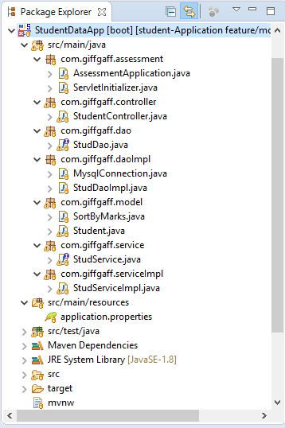

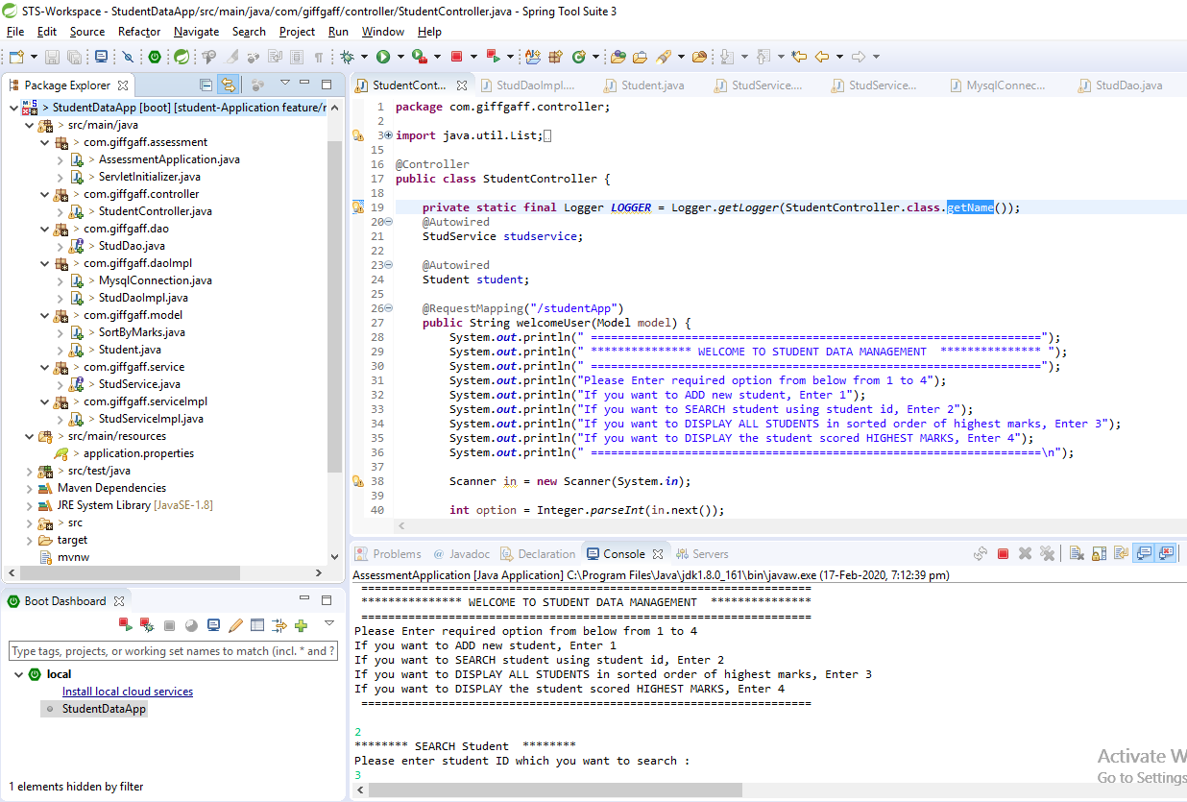

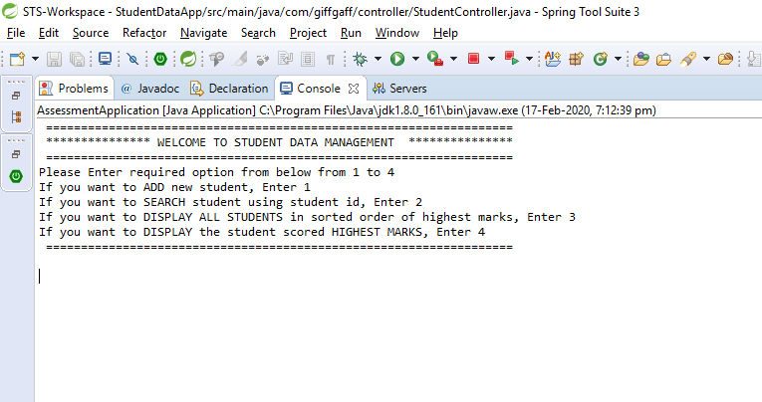

**Option 1:**

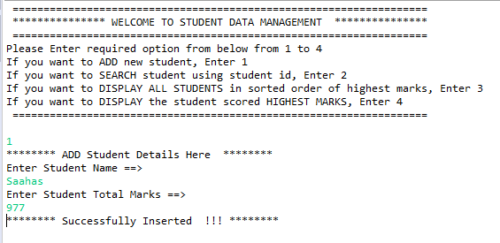

**Option 2:**

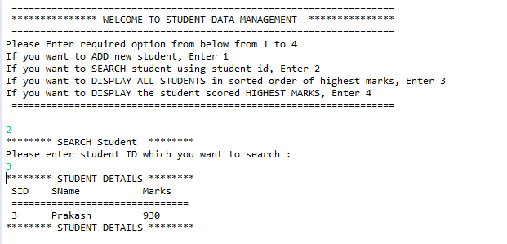

**Option 3:**

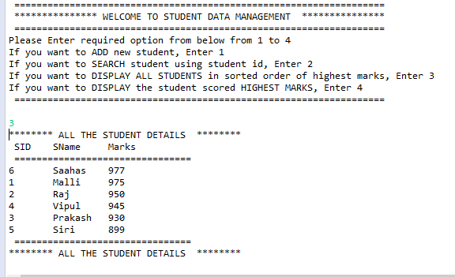

**Option 4:**

